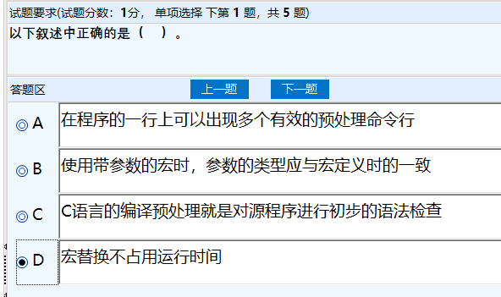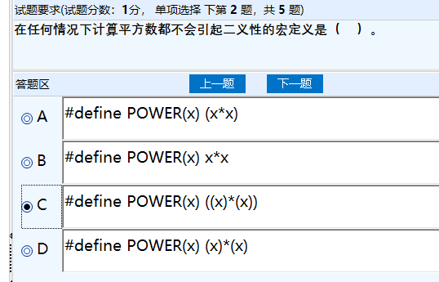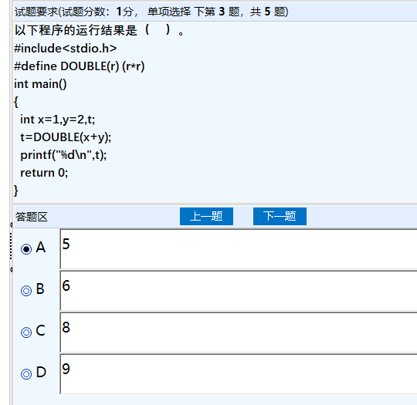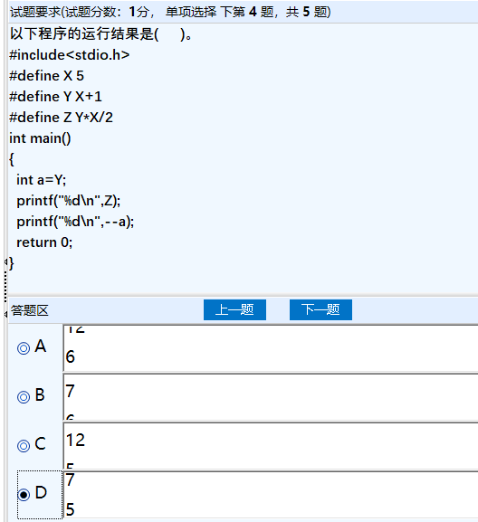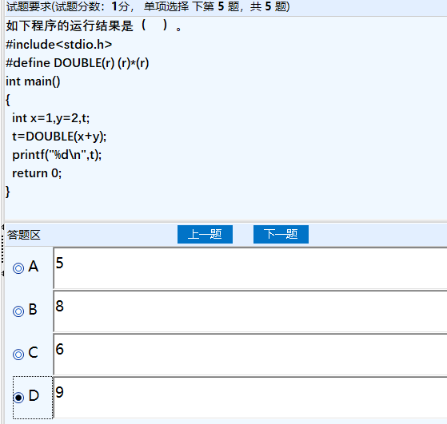宏替换不占用运行时间
#define POWER(x) ((x)*(x))
5
7 5
9

t=0
m%2==0
n/=10
k=fun(n)

low<=high
low=mid+1
high=mid-1
return -1
k=fun(a,n,m)

int x[][M],int y[][N],int z[][N],int n,int m
z[i][j]=0
k<m
c[N][N]
c[i][j]

int fun(int n,int m)
int count=0
i%j==0
j>i/2
return count

int x[],int y[],int z[],int m,int n
i<m
x[i]==y[j]
return k
int c[N]

int x[][N]
j<n
n-j
n-i
int a[N][N]

i<len-1
*(str+i)=t
fun(s,k)

double sum=1.0;
int a=1,b=1,temp;
int i;

for(i=2;i<=n;i++){
temp=a+b;
a=b;
b=temp;
if(i%2==0){sum-=1.0/sqrt(b);}
else{sum+=1.0/sqrt(b);}

}
return sum;

int total_scores[N] = {0};
int total_sum = 0;
int i, j;
double class_average;
*k = 0;
for (i = 0; i < n; i++) {
for (j = 0; j < m; j++) {
total_scores[i] += a[i][j];
}
total_sum += total_scores[i];
}
class_average = (double)total_sum / n;
for (i = 0; i < n; i++) {
if (total_scores[i] < class_average) {
b[*k] = total_scores[i];
(*k)++;
}
}
return class_average;

